HICKORY RIDGE ACADEMY
Parent Handbook and Compliance Agreement
2019-2020

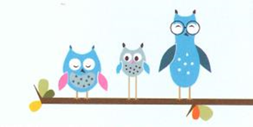

Parent(s)/Guardian(s): Please sign the following Compliance Agreement and return to the School Office.

Agreement in Response to Compliance

Name(s) of Child(ren) Enrolled

___________________________________________________________________________________
Name of Child Age of Child

___________________________________________________________________________________
Name of Child Age of Child

___________________________________________________________________________________
Name of Child Age of Child

___________________________________________________________________________________
Name of Child Age of Child

___________________________________________________________________________________
Name of Child Age of Child

I / We, the undersigned, have read the 2019-2020 Parent Handbook and Code of Compliance and understand the information therein.

___________________________________________________________________________________
Parent/Guardian Signature Date Signed

___________________________________________________________________________________
Parent/Guardian Signature Date Signed

